Coming to DCU | - BUKA  - •  - Project
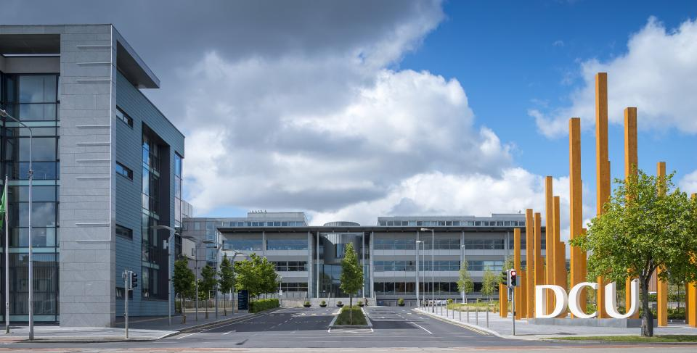 | 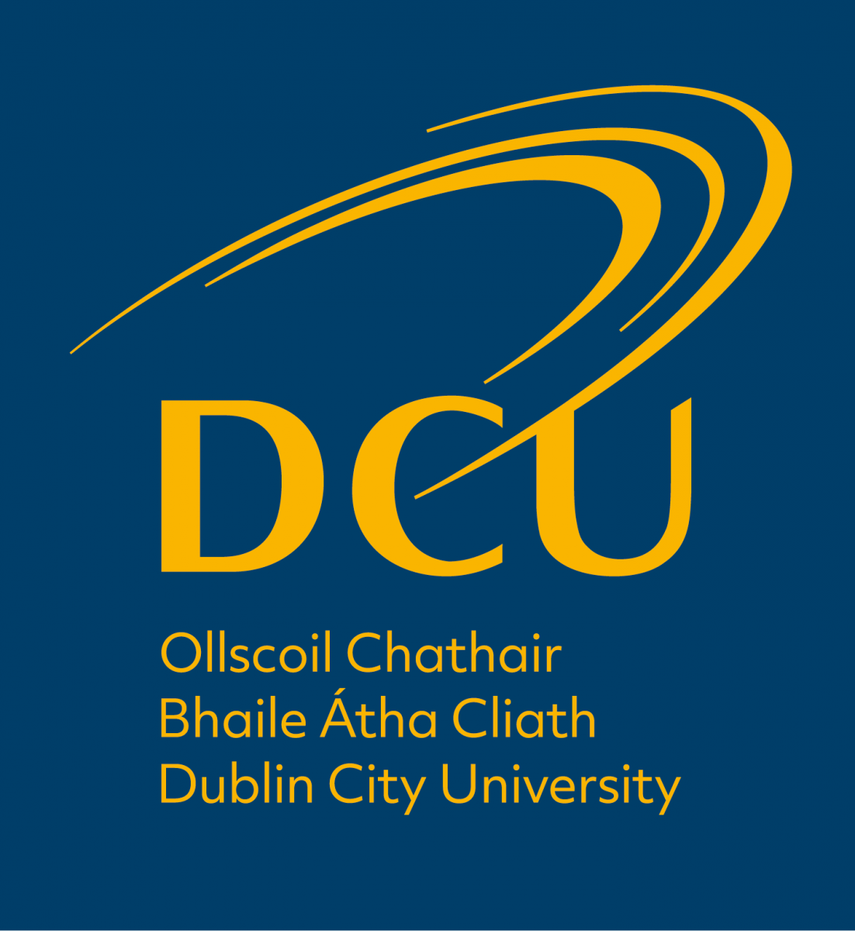

Contents
Programme of the Week 2
How to Get to DCU 3
Buses 3
Taxi 4
Where to Stay? 5
Hotel Options 5

Programme of the Week

Monday | Tuesday 04.10 | Wednesday 05.10 | Thursday 06.10 | Friday 07.10
Arrival in Dublin  Administrative/  bilateral meetings | 09.15 Progress review: TAMK Meetings | 09.15 Dissemination – Conference Planning & Handbook | 09.15 Progressing project evaluation | Tour of DCU campuses (St. Pats & All Hallows): Future & Past
 | 11.30 Welcome to DCU
 | 12.30 Lunch | 12.30 Lunch | 12.30 Lunch | Meeting Close
 | 14.00 - 16.00 Teaching Enhancement Unit: Key initiatives | 14.00-16.00 Dissemination - Handbook | 14.00 - 15.00 DCU Studio: Facilitating and supporting academic staff in developing high quality courses
 |  | Dinner – 19.00 The Woolen Mills Eating House

How to Get to DCU Glasnevin Campus

There are two entrances to the DCU Glasnevin campus where you will be joining us for the meetings. The Collins Avenue Entrance is closest to the building where we will likely spend most of our time, however the Ballymun road entrance is just a short walk from the Nursing Building (see the campus map at the end of this document).

Buses
A full listing of buses which drop-off at DCU is included below.
The following bus routes will take you TO DCU FROM the City Centre
DCU Ballymun Road Entrance:  9, 13, 11 & 155.  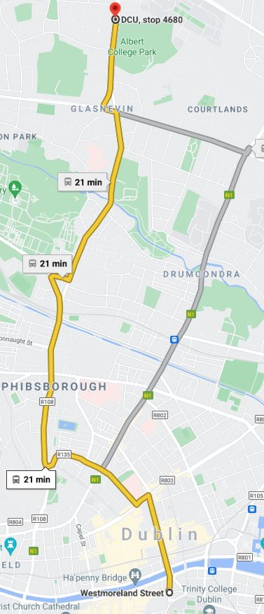 | Iveragh Road & 10 min walk to Collins Road Entrance:  1, 13, 16, 41 & 41C.  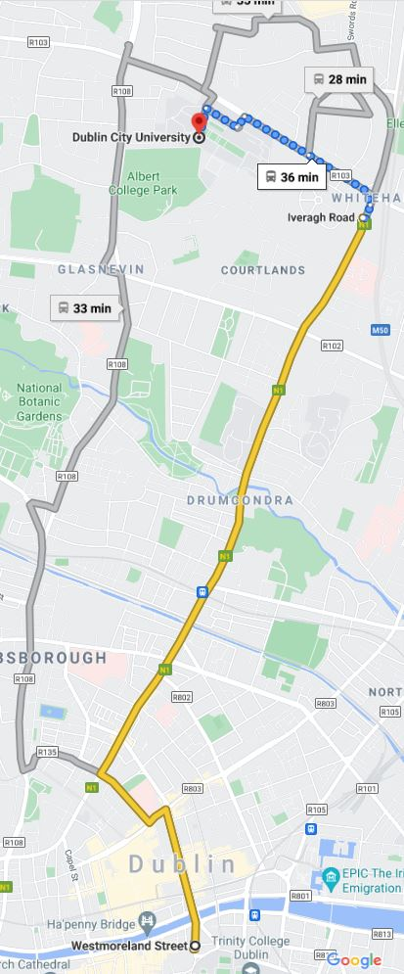 | Campus Center:  44  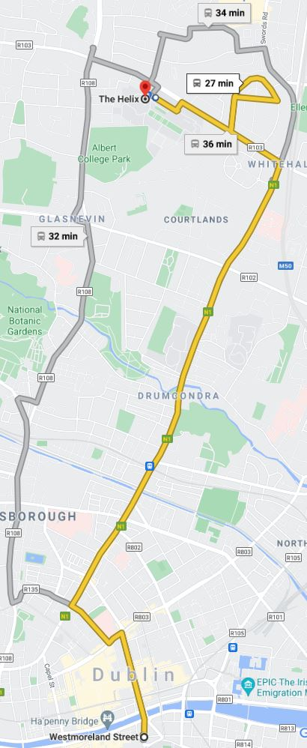
Note: from O’Connel bridge the 4 follows the same route as the 9 & 155 to DCU.

The following bus routes will take you TO DCU FROM the Airport T1 Zone 14
Shanvarna Road & 20 min walk to Collins Road Entrance:
16, 41.
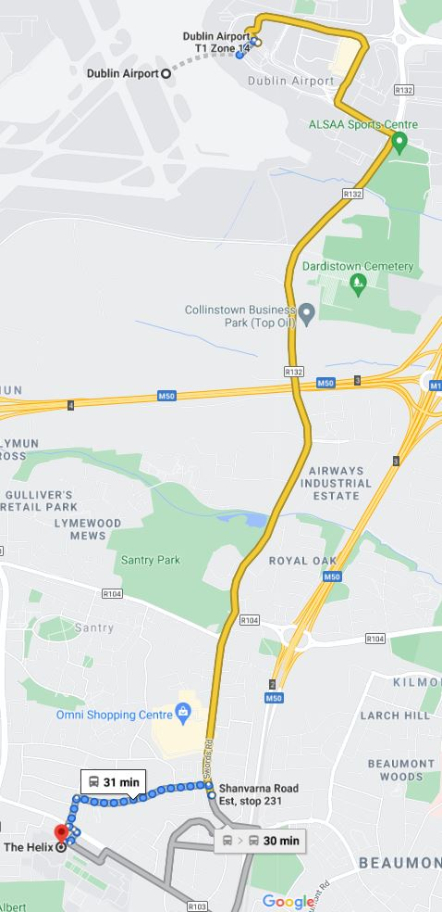s
To use public transport like Dublin Bus or the Luas you will need to pay with either exact cash fare (approx. €3.00 / trip) or you can use a Leap Card which is cheaper / trip and uses NFC to tap onto a bus.
To purchase a visitor Leap Card which will give you unlimited bus trips over 1, 3 or 7 days go to this website (https://about.leapcard.ie/leap-visitor-card) where you can purchase & have the card posted to your home before leaving for Dublin.

Taxi
Rather than public transport, you may also use Taxis to get place to place.
- VIP Taxi:
  - Website: https://viptaxis.ie/
  - Taxi App: https://viptaxis.ie/taxi-mobile-app/
- Lynk Taxi:
  - Website & Taxi App: https://www.lynk.ie/

Where to Stay?
It would be ideal to stay in hotels that are either close to DCU itself OR close to the city center as you have the greatest number of route options to the college from that location.

Hotel Options
Hotel prices correct as of 28th june 2022 are for 1 person / room & include bed & breakfast for 6 nights. Sale prices may be available on individual websites; hyperlinks provided below.
Hotel | Distance to DCU | B&B Prices (2nd – 8th Oct) | Transport Options
 |  |  | From Airport | To DCU
Dublin Skylon | 1.6KM | Single: €984  Twin: €1074 | 16, 16D, 41 | 1, 11, 13, 44
Bonnington | 2 KM | Single: €1680  Double / Twin: €1740 | 16, 16D, 33, 41 | 1, 13, 44
Maldron | 4.5 KM | Double: €1223 | 16, 16D, 33, 41 | 1, 4, 9, 44
Jurys Inn | 5.6KM | Double: €379.10 | 41, 660, 784 | 11, 13, 155
Academy Plaza | 5.7KM | Single: €755.64  Double: €809.64  Twin: €857.64 | 41, 660, 784 | 1, 13, 155
Hotel St. George | 5.8KM | Single/Double/Twin: €678.03 (Bar ONLY, no restaurant / breakfast incl.) | 16, 41, 660 | 1, 11, 13, 155

Alternative areas to search for hotels close to the city center include Temple Bar, Stephens Green. They are just a short walk from Westmorland Street where many buses leave for DCU.

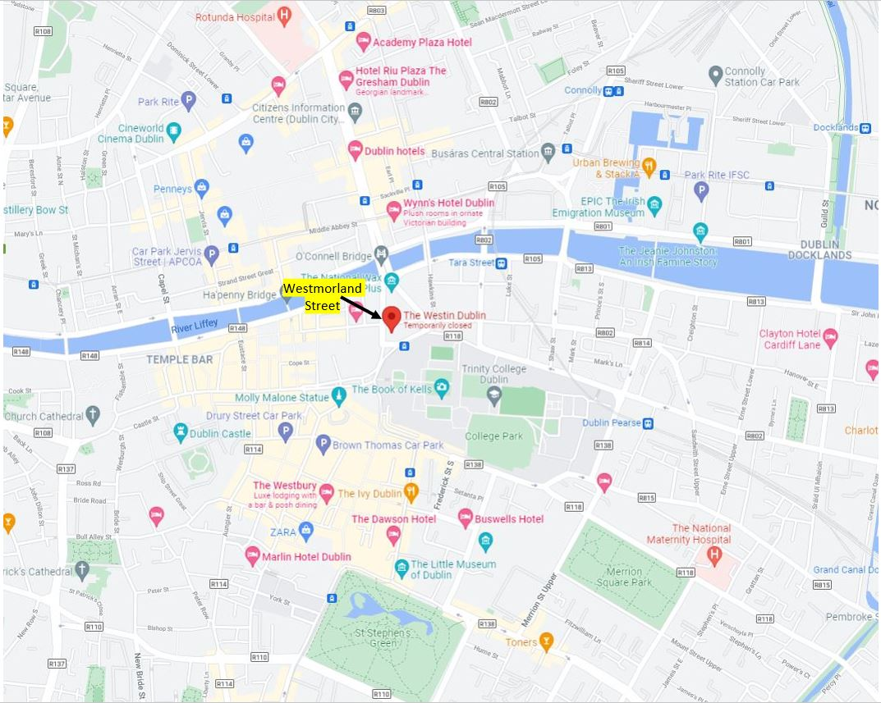
Our meetings will be held in H306 in the Nursing Building, just to the left at the Collins Ave. entrance
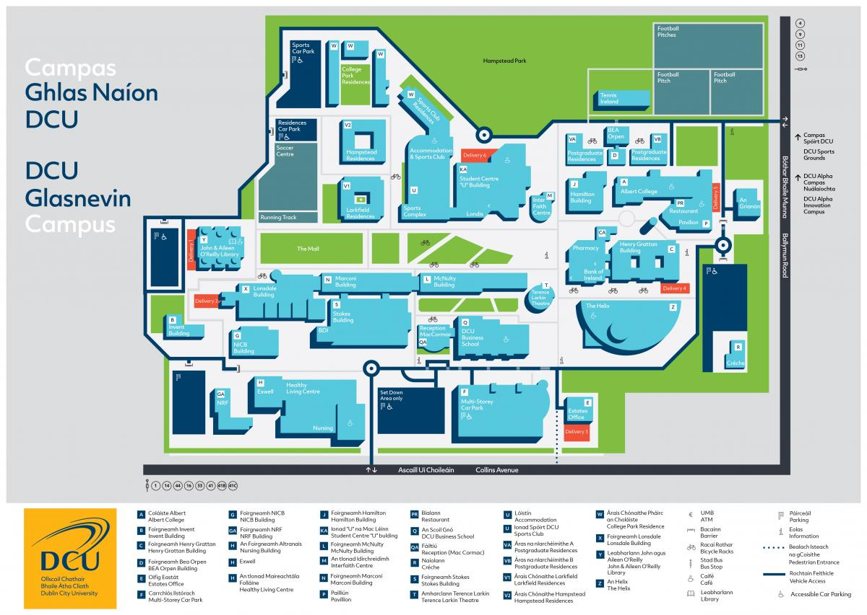
DCU St. Pats Campus: For Friday the 7th meeting at 10.00 in the ground floor of the library (at the café)
Location of St. Pats Campus library (very close to those staying in the Skylon and Bonnington)
